VISUALIZATION

Visualization is the graphical representation of data for better understanding and analysis. It helps to identify trends, patterns, and relationships in data. Python provides many visualization libraries such as Matplotlib, Seaborn, Plotly, and Bokeh. In this documentation, we will study Matplotlib and Seaborn.

MATPLOTLIB

Matplotlib is a Python library introduced in 2002 by John Hunter. It is mainly used for plotting 2D graphs and is built on NumPy.
A plot in Matplotlib contains:
1. Figure
2. Axes
3. Axis
4. Artists
Figure:
Figure is the container in which the plots are present. It can contain single or multiple plots.
Axes:
Axes are the actual plots attached to the figure. They represent the plotting area where data is displayed.
Axis:
Axis is responsible for generating scales, ticks, and limits on the graph.
Artists:
Everything visible in a figure such as text, lines, labels, and shapes are called artists.

PYPLOT:
Pyplot is a submodule of Matplotlib that contains functions used for creating different types of graphs such as line plots, bar charts, scatter plots, histograms, and pie charts.
We import pyplot as follows:
import matplotlib.pyplot as plt
import numpy as np

Some of the plots in Matplotlib:

LINE CHART
Line plots are basic charts where consecutive points are connected by a continuous line. plot() is used for creating line charts.

Code:
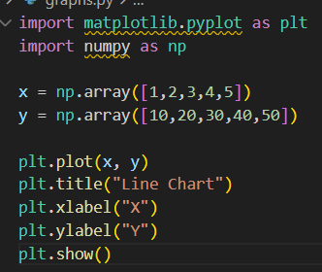

Output:
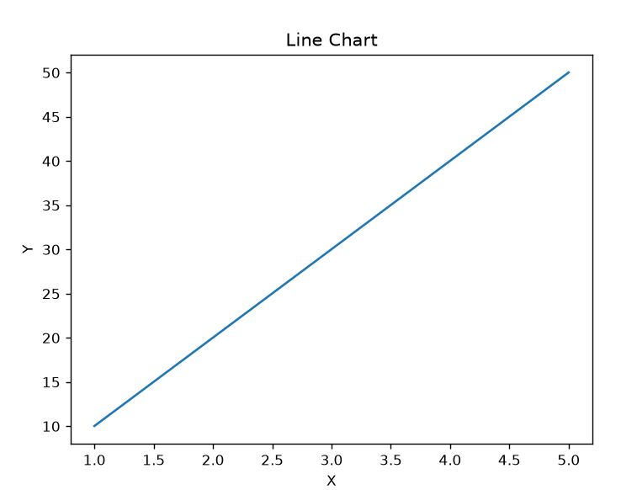

Description:
np.array() creates arrays of values.
plot() is used for plotting line charts.
title() sets the graph title.
xlabel() labels the x-axis.
ylabel() labels the y-axis.
show() displays the graph.

BAR CHART
Bar charts are used to compare values between different categories. bar() is used to create bar graphs.

Code:

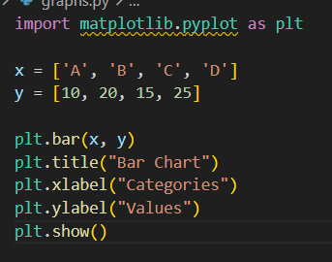

Output:
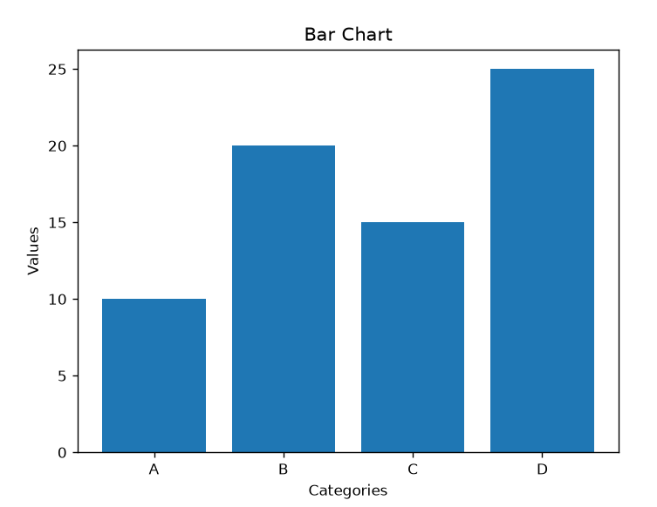

Description:
bar() is used for creating bar graphs.
It compares values across categories.
xlabel() labels categories.
ylabel() labels values.
show() displays the graph.

HISTOGRAM
A histogram is used to show the frequency distribution of numerical data. hist() is used for creating histograms.

Code:

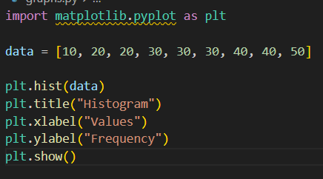

Output:
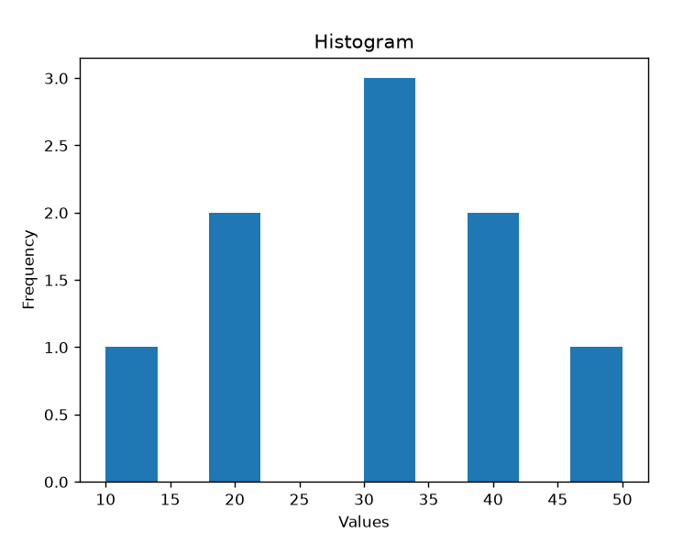

Description:
hist() is used to create histograms.
It shows how many times values occur.
xlabel() labels the values.
ylabel() shows the frequency.
show() displays the graph.

SCATTER PLOT
A scatter plot is used to show the relationship between two variables using points. scatter() is used for creating scatter plots.

Code:

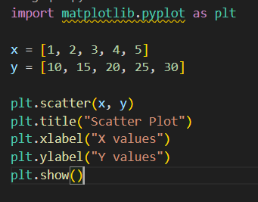

Output:
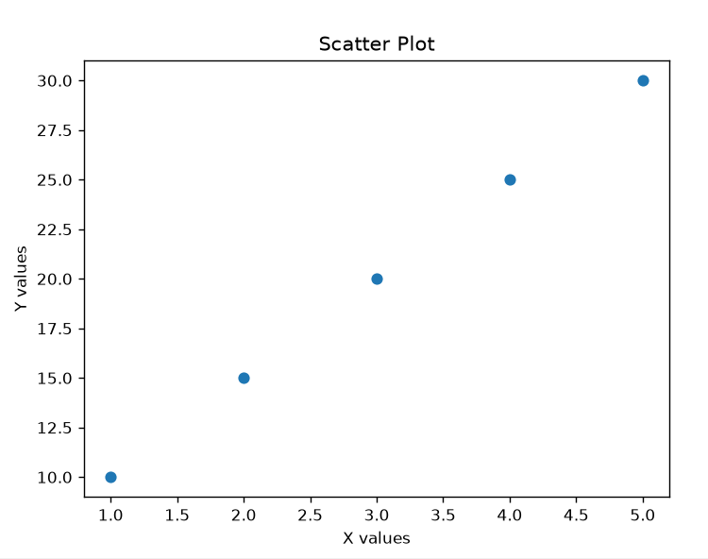

Description:
scatter() is used for plotting scatter plots.
It shows the relationship between two variables.
Each point represents one observation.
xlabel() and ylabel() label the axes.
show() displays the graph.

PIE CHART
Pie charts are used to represent parts of a whole using percentages. pie() is used for creating pie charts.

Code:

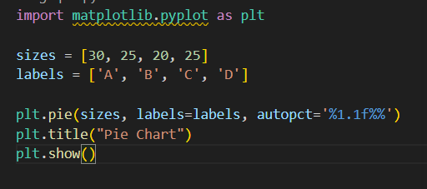

Output:
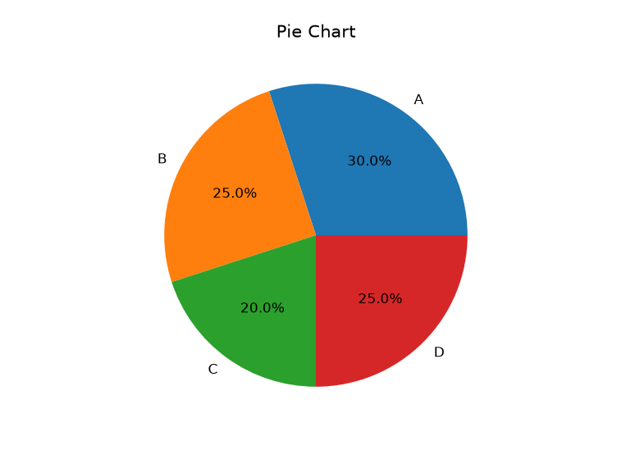

Description:
pie() is used for creating pie charts.
labels define each category.
autopct shows percentage values.
title() sets the chart title.
show() displays the graph.

SEABORN

Seaborn is a Python data visualization library built on top of Matplotlib. It provides a high-level interface for creating attractive and informative statistical graphics.
Seaborn offers better design, simpler syntax, and advanced statistical plots.

Some categories of Seaborn plots:
- Relational Plots
  - scatterplot()
  - lineplot()
- Categorical Plots
  - barplot()
  - boxplot()
  - countplot()
- Distribution Plots
  - histplot()
- Matrix Plots
  - heatmap()

SCATTER PLOT
Seaborn scatter plots are used to show the relationship between two variables with better visual styling.

Code:

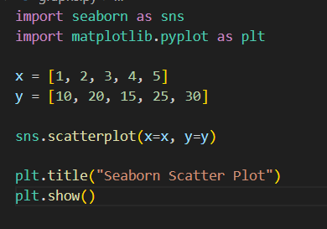

Output:
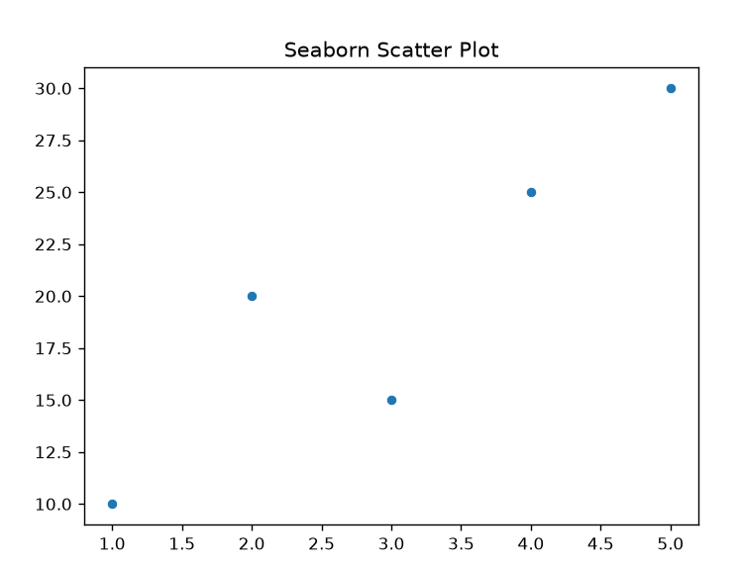

Description:
sns.scatterplot() is used for creating scatter plots in Seaborn.
It provides better styling than Matplotlib.
It helps visualize the relationship between variables.
show() displays the graph.

BOX PLOT
A box plot is used to show the distribution of data and identify outliers. It shows quartiles, median, and spread of data.

Code:

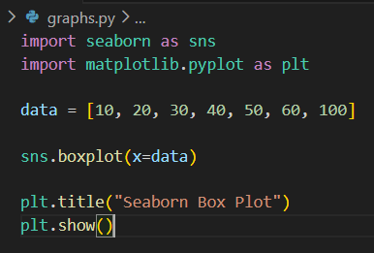

Output:
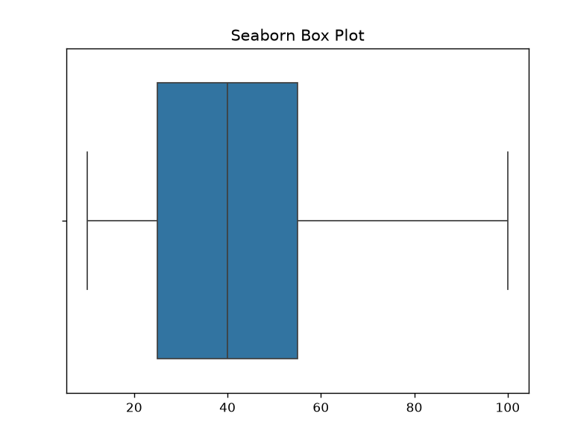

Description:
sns.boxplot() is used for creating box plots.
It shows quartiles, median, and spread of data.
Points outside the whiskers are outliers.
show() displays the graph.

HEATMAP
A heatmap is used to visualize data in the form of colors. It is mainly used to show correlation between variables.

Code:

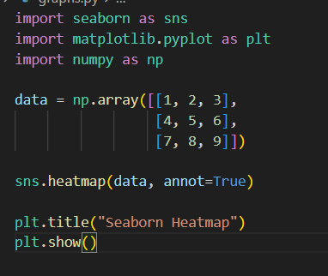

Output:
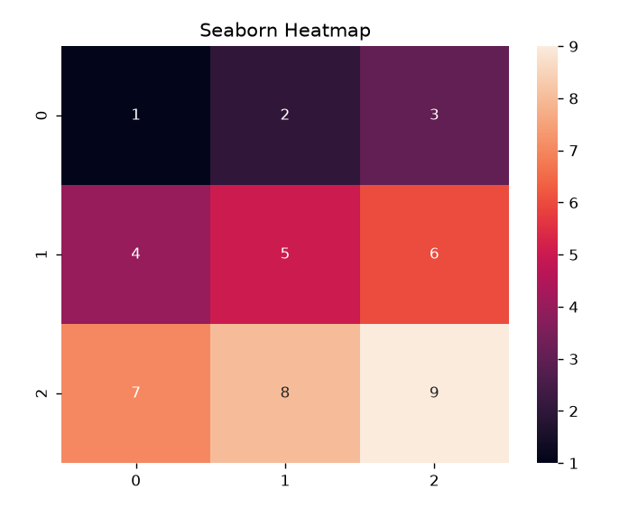

Description:
sns.heatmap() is used to visualize values using colors.
annot=True displays values inside each box.
Heatmaps are useful for correlation analysis.
show() displays the graph.

COMPARISON OF MATPLOTLIB AND SEABORN

Feature | Matplotlib | Seaborn
Type | Core plotting library | Built on Matplotlib
Ease of Use | Moderate | Easy
Customization | High | Medium
Visual Appearance | Basic | Attractive
Best Use | General plotting | Statistical visualization
Code Complexity | More lines of code | Less lines of code

Conclusion:
Matplotlib provides greater flexibility and customization, while Seaborn makes visualization easier and more visually appealing. Both libraries are important tools for data analysis and visualization.s

